SOFTWARE
DESIGN
DESCRIPTION

LEARN-LINK
Prepared by
Aswin Jim Thuruthippilly
Christin Jose Biju
Johnson V Mathew
Rohan Mannaraprayil

24/02/2025

Contents
1. Overview 2
1.1 Scope 2
1.2 Purpose 3
1.3 Intended audience 3
1.4 References 3
2. Definitions, Acronyms and Abbreviations 3
3. Conceptual Model for Software Design Descriptions 5
3.1 Software Design in Context 5
3.2 Software Design Descriptions within the Life Cycle 5
3.2.1 Influences on SDD Preparation 5
3.2.2 Influences on Software Life Cycle Products 5
3.2.3 Design Verification and Design Role in Validation 6
4. Design Description Information Content 6
4.1 Introduction 6
4.2 SDD Identification 7
4.3 Design Stakeholders and Their Concerns 7
4.4 Design Views 7
4.5 Design Viewpoints 7
4.6 Design Elements 8
4.7 Design Overlays 9
4.8 Design Rationale 9
4.9 Design Languages 9
5. Design Viewpoints 9
5.1 Introduction 9
5.2 Context viewpoint 9
5.2.1 Design concerns 10
5.2.2 Design Elements 10
5.2.3 Example Languages 12
5.3 Composition Viewpoint 12
5.3.1 Design Concerns 12
5.3.2 Design Elements 13
5.3.3 Example Languages 13
5.4 Logical Viewpoint 13
5.4.1 Design Concerns 13
5.4.2 Design Elements 14
5.4.3 Example Languages 14
5.5 Dependency Viewpoint 14
5.5.1 Design Concerns 15
5.5.2 Design elements 15
5.5.3 Example Languages 15
5.6 Information Viewpoint 15
5.7 Patterns Use Viewpoint 15
5.8 Interface Viewpoint 15
5.8.1 Design Concerns 15
5.8.2 Design Elements 16
5.9 Structure Viewpoint 17
5.9.1 Design Concerns 17
5.9.2 Design Elements 17
5.9.3 Example languages 17
5.10 Interaction viewpoint 18
5.10.1 Design Concerns 18
5.10.2 Design Elements 18
5.10.3 Examples Languages 19
5.11 State Dynamics Viewpoint 19
5.11.1 Design Concerns 19
5.11.2 Design elements 20
5.11.3 Example languages 20

1. Overview

1.1 Scope
The developed product, Learn-Link, is a web application designed to enhance academic collaboration by integrating real-time communication, AI-driven insights, and content-sharing capabilities. It addresses challenges users face in organizing ideas, streamlining their learning process, and promoting meaningful discussions. The system will be modeled using UML diagrams and designed according to IEEE 1016-2009 standards. The objective is to provide an intuitive and efficient knowledge-sharing platform that boosts productivity and fosters academic excellence.

1.2 Purpose
The purpose of this document is to describe the software design of Learn-Link, enabling structured development and providing insights into the system’s architecture, functional and data structure, and interactions. This document serves as a guide for software implementation, testing, and maintenance. It ensures that the system meets the requirements outlined in the Software Requirement Specification (SRS) document while facilitating efficient knowledge sharing and collaborative learning.

1.3 Intended audience
The intended audience of this document includes all key stakeholders, such as the development team , the project owner, the project mentor , faculty members of VJCET, and the evaluators of the project.

1.4 References
- IEEE. IEEE Std 1016-2009 IEEE Standard for Information Technology – System Design –
Software Design Descriptions. IEEE Computer Society, 2009
- Software Specification Requirements (SRS) Document of Learn-Link prepared by Aswin Jim Thuruthipilly, Christin Jose Biju,Johnson V Mathew,Rohan Mannaraprayil.
- https://www.ycombinator.com

2. Definitions, Acronyms and Abbreviations
All the definitions, acronyms and abbreviations which are used in this document are described in
the following table.

Block diagram | A diagram showing in schematic form the general arrangement of the parts or components of a complex system or process.
Class Diagram | A type of static structure diagram in UML that describes the structure of a system by showing the system's classes, their attributes, operations (or methods), and the relationships among the classes
DDB | Distributed Database
HTTPs | Hypertext Transfer Protocol Secure
IDE | Integrated Development Environment
IEEE Standard | International Electric Electronic Engineering Standards 1016-2009
PC | Personal Computer
SQL | Structured Query Language
SDD | Software Design Description
SDK | Software Development Kit
SRS | Software Requirement Specification
Stakeholders | Any person with an interest in the system who is not a developer of the system.
StarUML | Design tool of diagrams
State Transition  Diagram | A type of static structure diagram in UML that describes the transition of the system functions
UI | User Interface
Use Case  Diagram | A type of static structure diagram in UML that describes user's interaction with the system
User | Person who wants to use the system
User Interface | An interface that our system contacts with the user of the system. It gets all needed information for its running, from user to our system.
XML | Extensible Markup Language

3. Conceptual Model for Software Design Descriptions
This section includes basic Learn-Link system terms, concepts, and the context in which the Software Design Description (SDD) is prepared. The purpose of the conceptual model is to provide a better understanding of system terminology and the software life cycle that the system resides in. The conceptual model also provides information about stakeholders who will use the SDD and how the SDD will be utilized.

3.1 Software Design in Context
Learn-Link will be designed as a web application that integrates AI-driven insights and collaboration features. The system will be implemented using modern web technologies such as React.js for the frontend, Node.js with Express.js for the backend, and Auth0 for secure authentication. AI-powered functionalities will leverage the Gemini API for text and media processing. The system aims to deliver accurate and relevant educational content efficiently, ensuring users can streamline their learning process effectively.
Learn-Link is planned as a web-based application accessible through web browsers on any personal computer with an internet connection. The system will be compatible with major operating systems, including Linux, Windows, and macOS. The application’s performance depends on computational specifications such as browser capabilities, network speed, and server efficiency, ensuring optimal responsiveness and seamless user experience.

3.2 Software Design Descriptions within the Life Cycle
This software will be created following IEEE standards. The primary milestones of this system are requirements analysis, design description analysis, implementation and finally verification and validation.

3.2.1 Influences on SDD Preparation
The first influence on the software design process is the Learn-Link SRS document. In the SDD, we consider the product perspective, functional and non-functional requirements, and interface requirements included in the SRS. Given specifications and possible new requests from stakeholders will guide the design process of this system.

3.2.2 Influences on Software Life Cycle Products
All interfaces should be designed first. Before officially launching the system, user interfaces should be presented with sample examples to stakeholders. As a result, stakeholders can provide feedback and requirements for refinement. Finally, the system can be published as a fully functioning web application. Furthermore, the SDD will guide the development process. Based on the document, some requirements may be modified in response to stakeholder feedback, ensuring a more precise alignment with project goals after each development sprint.

3.2.3 Design Verification and Design Role in Validation
Verification involves testing Learn-Link to determine if it meets design specifications. This process includes reviewing the SRS and SDD documents to confirm correctness. Functional and non-functional requirements will be evaluated to ensure proper implementation. Additionally, design viewpoints in the final Learn-Link system will be assessed to confirm alignment with SDD specifications.
Validation ensures that Learn-Link remains consistent with its core objective—enhancing academic collaboration through AI-driven tools and real-time communication. Stakeholders and developers will jointly assess whether the system meets its intended goals. Upon completing the implementation, testing will be conducted based on SDD-influenced test plans and cases.

4. Design Description Information Content

4.1 Introduction
The software design description of Learn-Link analyzes how the system will be designed and implemented. This section explores SDD identification, identified design stakeholders and concerns, related design viewpoints, design views, overlays, rationale, and design languages. Furthermore, it includes design elements such as design entities, attributes, relationships, and constraints.

4.2 SDD Identification
Learn-Link is planned for release after validation and verification tests. A prototype will be available during the development phase for evaluation. Modification and distribution of Learn-Link can only be performed by the development team, due to exclusive rights. The scope, references, context, and summary of the system are found in the “Overview” section, while definitions, acronyms, and abbreviations are available in the “Definitions” section

4.3 Design Stakeholders and Their Concerns
Stakeholders comprise a developer team who working on Learn-Link at the Viswajyothi College of Engineering and Technology Department of Computer Science Engineering members. Mainly concerns of the stakeholders are accuracy of the information which is provided by the system because it must be perfect. In addition, this project may be a little difficult to design and develop.

4.4 Design Views
Design views help design stakeholders about focusing on design details from a specific perspective and meeting relevant requirements. Each identified design concern must be the topic of at least one design view so that SDD is complete. Each design concern identified in the previous subsection is the topic of most of the design views in this document; thus, this SDD is completed. For example, concerns about cost are a topic of composition view. Moreover, concerns about accuracy of data are a topic of logical view. In this document, context, composition, logical, dependency, information, patterns use, interface, interaction and state dynamics views will be explained in section 4.5 as their corresponding viewpoints. For some views, relevant UML diagrams will be shown in order to clarify.

4.5 Design Viewpoints
This document describes context, composition, logical, dependency, information, patterns use, interface, structure, and interaction and state dynamics viewpoints.
Context Viewpoint: It describes the relationships, dependencies and interactions between the system and its environment such as users and other interacting stakeholders. Interactions between the system and its actors are very intense, hence concerns of this viewpoint are important and suitable for the Learn-Link. It includes a use case, context and block diagram showing the system boundary.
Composition Viewpoint: It describes how the design subject split up into its components and which roles these components have. It can be used in estimating cost, staffing and scheduling duties of a development team. It includes a deployment and component diagram.
Logical Viewpoint: It describes class structures, interactions between them and how they are designed and implemented. Also, it supports development and reuse of existing logical components. It includes a class diagram which defines objects and classes, and relationships between them.
Dependency Viewpoint: It describes the components of the system and dependencies between these components. It gives information about shared information and order of execution of these components.
Information Viewpoint: It describes data items, data types and classes, data stores and access mechanisms. It gives information about data attributes.
Patterns Use Viewpoint: It describes design patterns and usage of design patterns which meet design ideas of the project.
Interface Viewpoint: It describes the details of external and internal interfaces. It provides information to the designers, programmers and testers before proceeding with the detailed design of the system. This also provides designers, programmers and testers to use the system as a random user.
Interaction Viewpoint: It describes the sequence of actions and how, why, where and at what level actions occur in the system. It is preferred to use state dynamics views in detail for this project.
State Dynamics Viewpoint: It describes the internal behavior of the system. System dynamics include modes, states, transitions and reactions to events. It gives information step by step about the system operation. It includes a state machine diagram which defines conditions, states, transitions and relationships between them.

4.6 Design Elements
Any item which appears in a design view is named as design elements. It may be one or some of these subcases; design entity, design relationship, design attribute and design constraints. All design elements are defined with subcases under their corresponding viewpoint in section 5 of the software design description.

4.7 Design Overlays
Design overlays are usually used to add information to the existing views. This concept will be explained clearly, when necessary, in the design viewpoints section which is 5.

4.8 Design Rationale
The Object-Oriented approach was chosen while designing because by this way the hardware part and software part will be combined easily. Software part includes parsing and reading notes and transmitting data. To design these lots of packages were used. These packages are connected between each other and they can be controlled separately. Furthermore, for the hardware part a package was used and there is another package to combine software and hardware parts.

4.9 Design Languages
In this document Unified Modeling Language (UML) will be used as the modeling language for the diagrams. The modeling language is used for emphasizing the static structure and dynamic behavior of the system.

5. Design Viewpoints

5.1 Introduction
This section provides several main design viewpoints of Learn-Link with their corresponding design concerns and appropriate design languages. Context, composition, logical, dependency, information, patterns, interface, structure, and interaction viewpoints are defined in the following subsections. Short descriptions relating to a minimal set of design entities, design relationships, design entity attributes, and design constraints are provided for each viewpoint.

5.2 Context viewpoint
The context viewpoint of Learn-Link illustrates the functions provided by the system within an explicit context. The services define the relationships, dependencies, and interactions between the system and its environment, including users and other stakeholders.

5.2.1 Design concerns
Design concerns include services, actors, and system boundaries. Learn-Link consists of a web-based user interface. There are two types of actors who interact with the system: registered users who access the platform regularly and guest users who use it occasionally. Therefore, constraints may differ based on the user type.
Registered users interact with Learn-Link through a secure authentication process, gaining access to features like real-time collaboration, AI-powered tools, and content sharing. Guest users, on the other hand, have limited access to publicly available resources. The system interface ensures smooth information flow between users and Learn-Link’s core services. The diagram below illustrates the system boundary, including relationships between users and key system components.
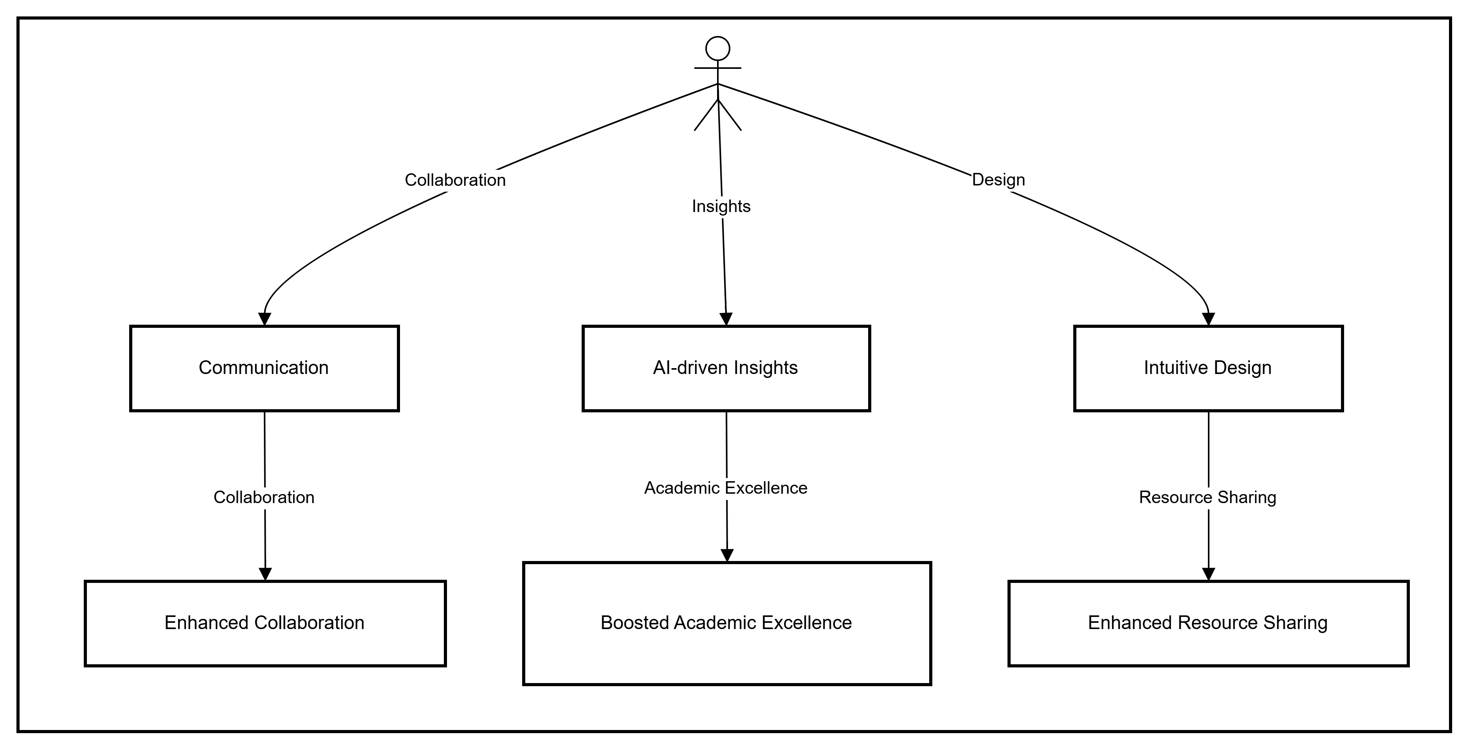

Figure 1: Block Diagram of the Learn-Link

5.2.2 Design Elements
One of the design entities is the actor of the system, user. Stakeholders are other design entities of the Learn-Link. They consist of a project management and developer team. Below diagram shows the design relationship which includes provided input and received output between the user and the other major components of the system.

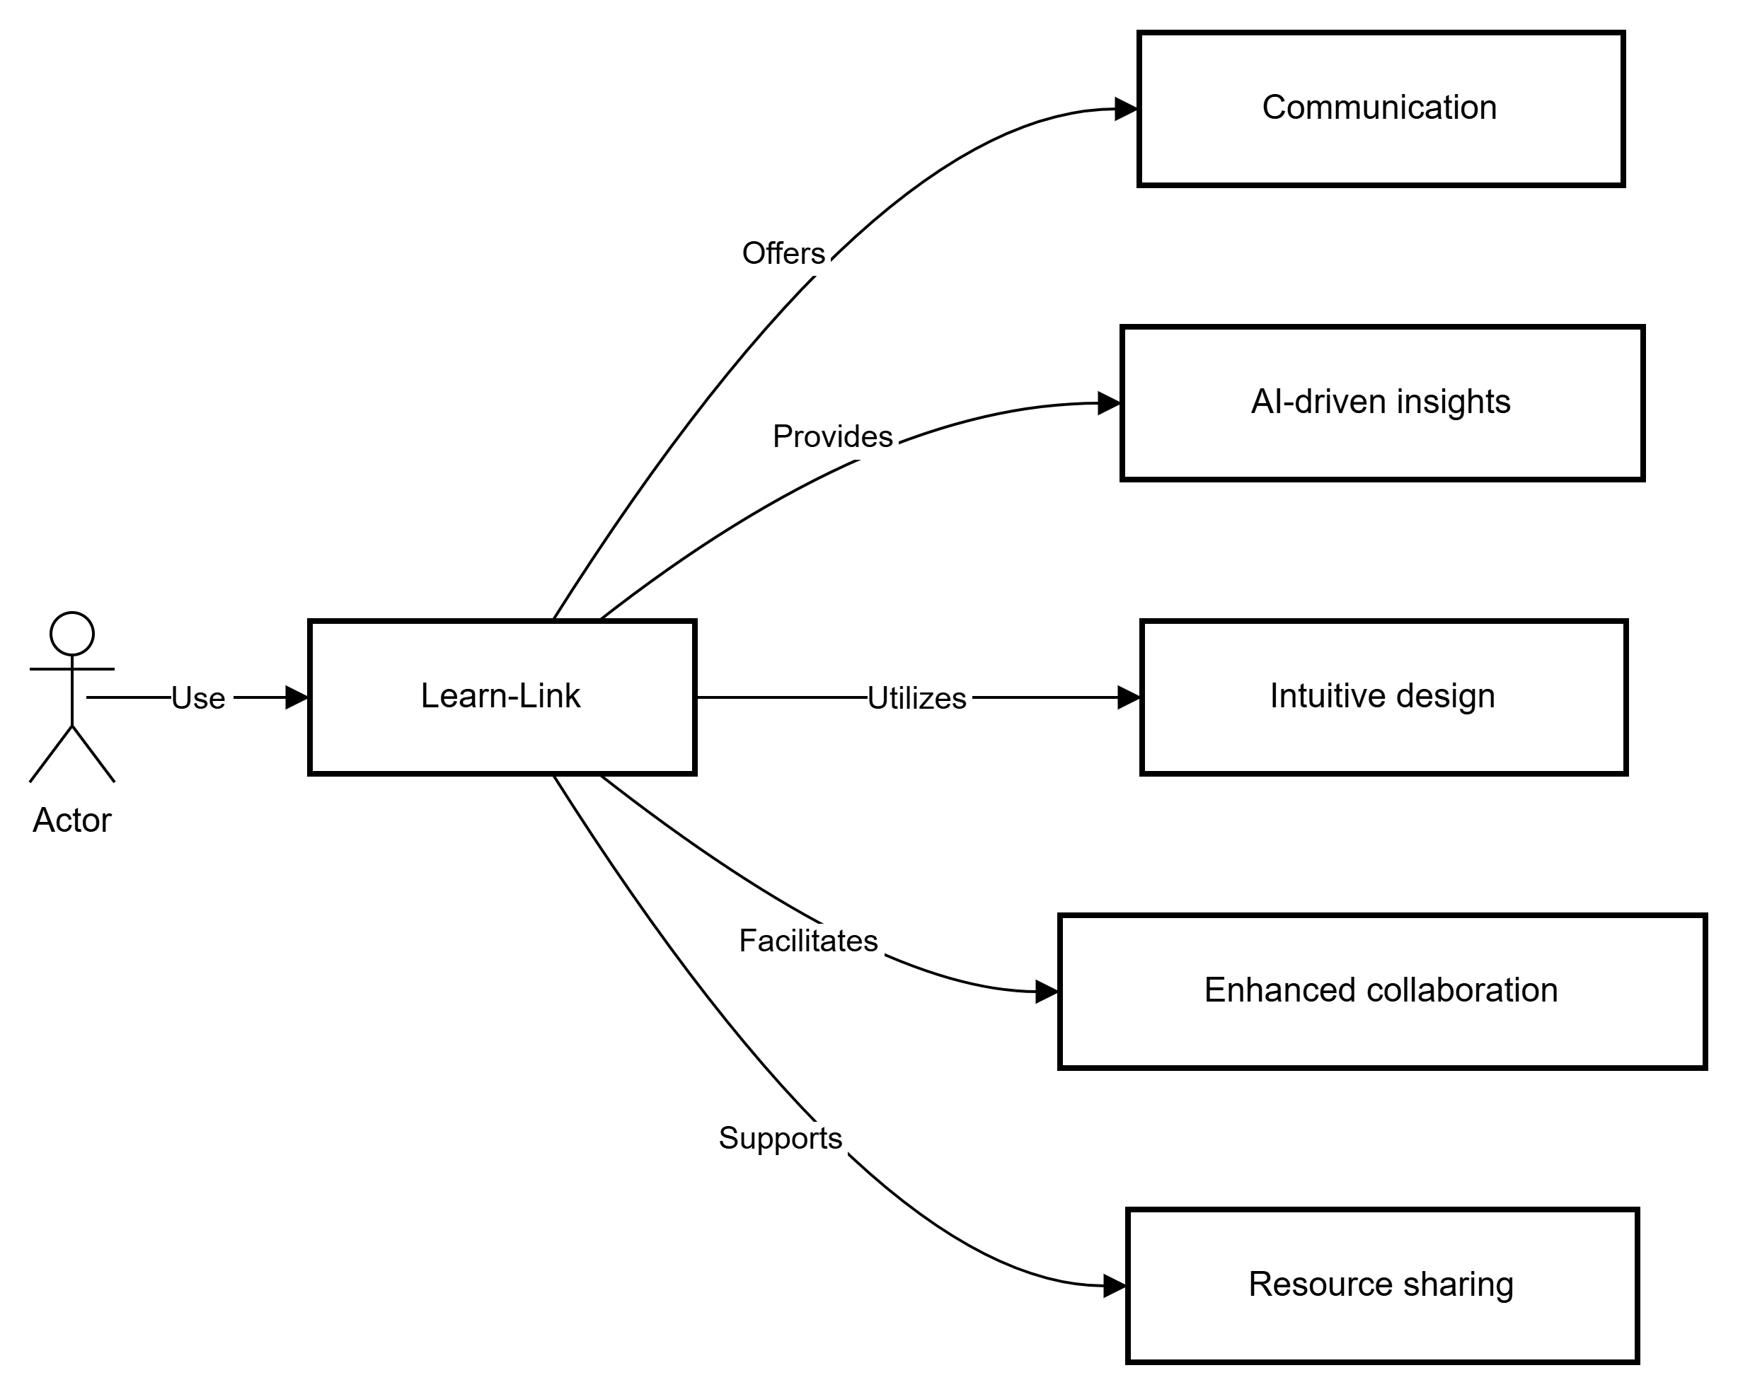

Figure 2: Context Diagram of the Learn-Link

Figure 3 given below describes system interaction and functionality with the user. There are two types of users, ones who use all the functionalities related to the system (Regular Users) and those who access selected functionalities (Temporary Users).

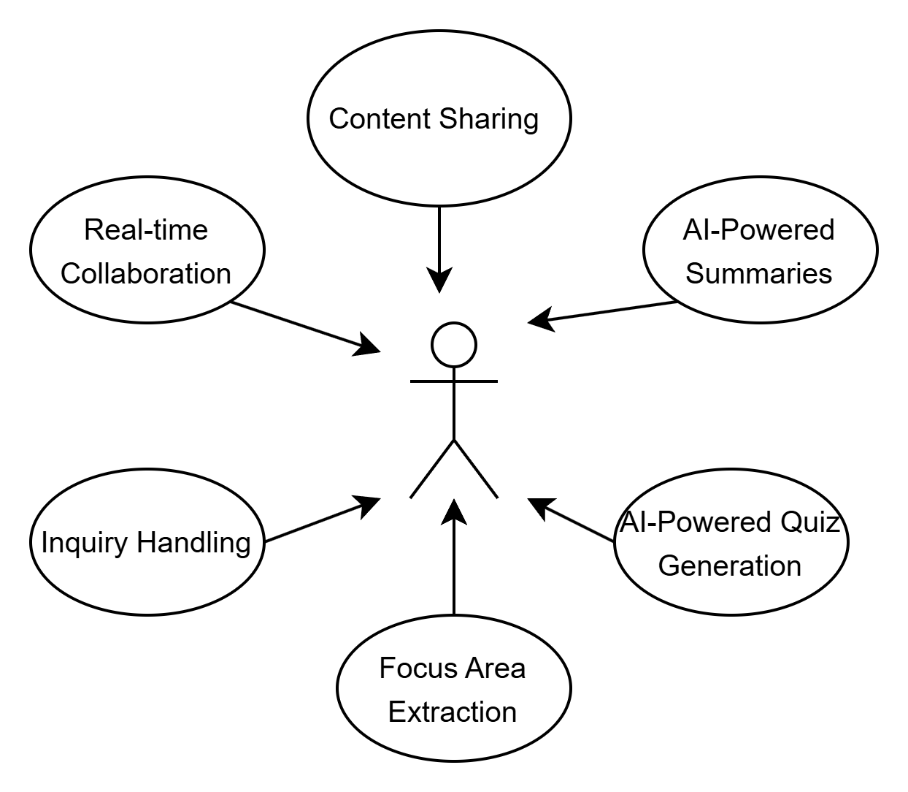

Figure 3: Use Case Diagram of the Learn-Link

5.2.3 Example Languages
The diagrams given in the previous subsections are created by the UML. One of these diagrams is the block diagram describing interrelationships of a system. Another one is the context diagram defining the boundary between the system and its environment. The last one of them is the use case diagram showing user interactions with the system.

5.3 Composition Viewpoint
The purpose of the composition viewpoint of Recommendation System is to define the system as a composition of its subsystems. The project is formed by 4 main submodules: GUI,AI integration,Collaboration,tesing. Detailed explanation about the relations between these modules will be explained in coming sections.

5.3.1 Design Concerns
With the help of information in composition viewpoint, system stakeholders and developer team can plan and control the software product. The design of this project is structured into sub-modules and components such as interface and other packages. The project is managed by planning, monitoring and controlling these components. All acquired information about the project provides estimated cost, staffing, and schedule for the development effort.
Below UML deployment diagram shows run-time (physical) decomposition of the system.

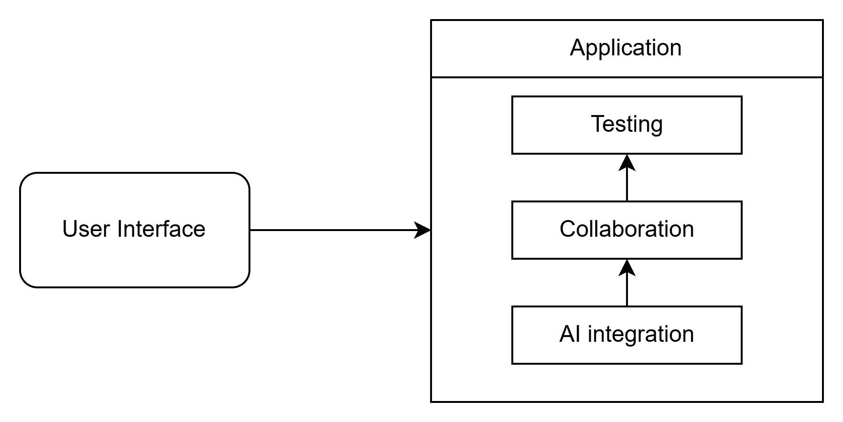

Figure 4: Deployment Diagram of the Learn-Link

5.3.2 Design Elements
The project is formed of interfaces and classes inside packages as design entities. There are three packages which are User Interface, AI services and communication manager which allow the system to be run as an application. A figure showing the relations between these modules is given below:

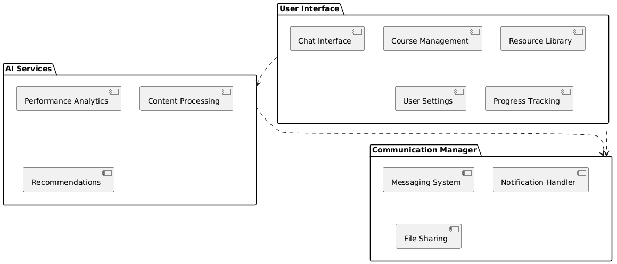
Figure 5: Component Diagram of the Learn-Link

5.3.3 Example Languages
A component diagram showing functional (logical) decomposition of the system and a deployment diagram showing run-time (physical) decomposition of the system have been given in the previous sections by using UML modeling language.

5.4 Logical Viewpoint
The purpose of the Logical viewpoint is to elaborate existing and designed types and their implementations as classes and interfaces with their structural static relationships. For each entity, there will be a diagram to overview the entity and then a table that name, return type; visibility of the entity/class diagram is shown in. Also, definitions of each element is provided. After all elements are explained, the class diagram that shows relationships between the classes is drawn.

5.4.1 Design Concerns
The logical viewpoint is employed to show the development and reuse of abstractions and their implementations. This means, object-oriented programming simplifies to maintain and modify existing code while new objects are created. Since identifying object classes is often a difficult part of object-oriented design, during the implementation phase of the project there can be some changes in object identification.

5.4.2 Design Elements
The project has three packages named User Interface, AI services, communication manager. All packages have different classes. All package connections and their classes can be seen in the figure: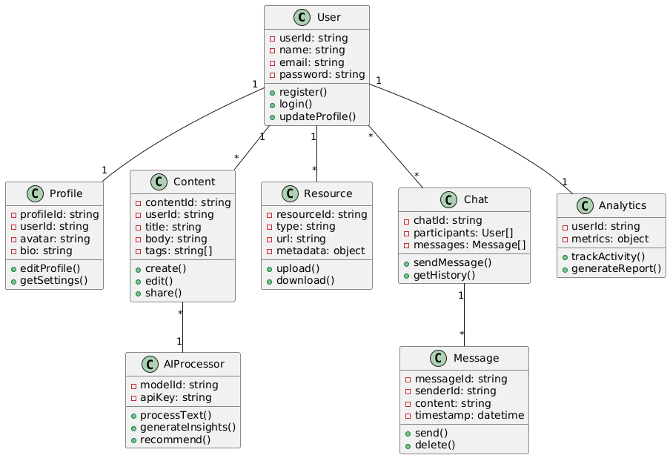

Figure 6: Class Diagram of the Learn-Link

5.4.3 Example Languages
A class diagram which describes the structure of a system by showing classes of the system has been given in the previous sections by using UML modeling language.

5.5 Dependency Viewpoint
The Dependency viewpoint specifies the relationships of interconnection and access among entities. These relationships include shared information, order of execution, or parameterization of interfaces.

5.5.1 Design Concerns
Dependency viewpoint helps maintainers to isolate entities causing system failures or resource bottlenecks. In producing the system integration plan, the system is identified with the sub-modules and the components which are dependent on each other.

5.5.2 Design elements
The product is composed of the user interface and classes inside packages as design entities. Detailed explanation about the dependency between the entities and the modules are explained with the component and deployment diagrams in the section 5.3.2.

5.5.3 Example Languages
The component diagram showing functional (logical) decomposition of the system in the section 5.3.2 and the package diagram depicting the dependencies between the packages in the section 5.9.2 are created by UML.

5.6 Information Viewpoint
The information viewpoint of the Learn-Link project, based on the provided document,would focus on the data and information that the system will manage and process. It would describe the key data entities, their attributes, and the relationships between them.

5.7 Patterns Use Viewpoint

The Patterns Use Viewpoint for Learn-Link would focus on identifying and documenting the recurring solutions to common design problems within the platform's architecture. Essentially, it's about recognizing and naming the patterns they employ.

5.8 Interface Viewpoint
The Interface Use Viewpoint of the Learn-Link project focuses on defining the interactions and dependencies between the different modules or components of the system. It aims to clarify how these modules communicate and exchange information with each other to achieve the overall functionality of the platform. Clients interact through user interface and provide necessary information’s for calculation procedures and those information’s are stored in the database.
.

5.8.1 Design Concerns
Interface viewpoint provides information to the designers, developers and testers before proceeding with the detailed design of the system. It also informs them about how cooperating entities will interact. With the ease of each interface descriptions, designers and developers can know internal and external connections of system to develop it. This contributes ease of maintenance.

5.8.2 Design Elements
In this subsection, user interface of the home page of the Learn-Link is shown. In addition, usage of these interfaces is given in details.

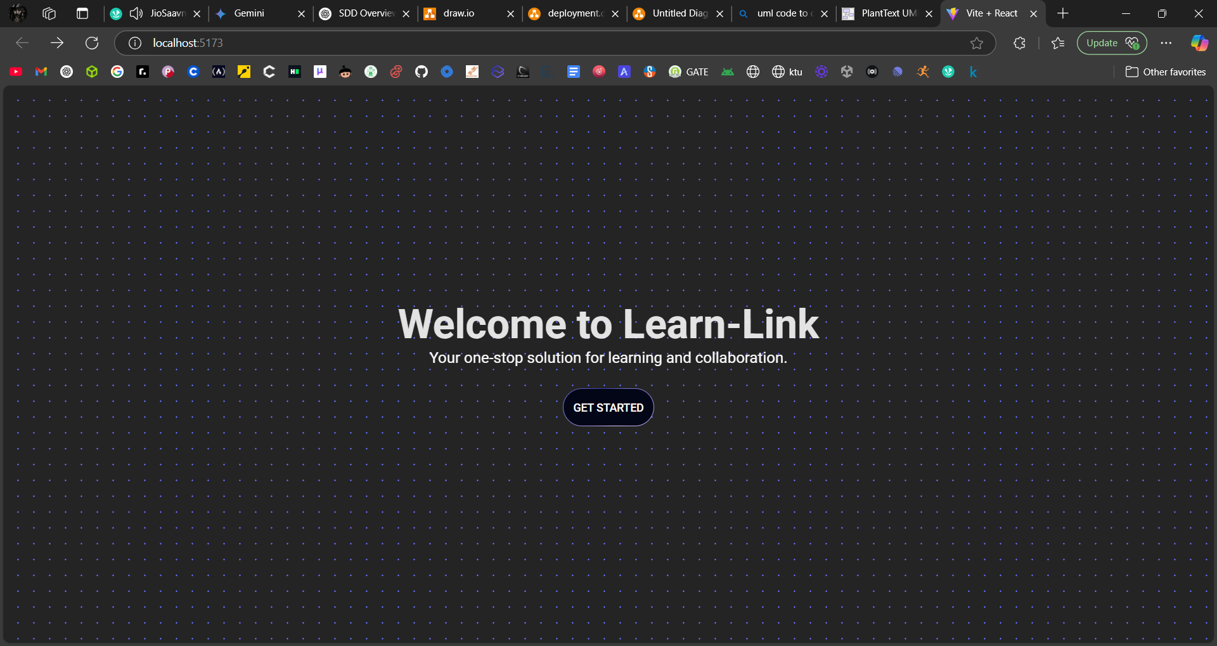
Figure 7: User Interface of Learn-Link

Figure 7 shows the only interface of the Learn-Link. Upon arriving at the Learn-Link website, users are greeted with a welcoming interface designed to cater to their varying needs. The primary focus of this initial interaction is to quickly guide users toward accessing the platform, offering two distinct paths. For those curious to explore Learn-Link without immediate commitment, the "Quick Access" option, labeled "Try it out," provides a guest pass to sample core functionalities. This limited preview allows potential users to experience the platform's intuitive design and get a taste of its capabilities, ultimately encouraging them to create a full account for unrestricted access. Alternatively, users seeking the complete Learn-Link experience can choose the "Full Access" route, prompting them to either sign up for a new account or log in if they are already registered. This path unlocks the full suite of features, including real-time collaboration tools, AI-powered insights for smarter decision-making, comprehensive content sharing and management, and personalized profiles to enhance the learning journey. The interface is carefully crafted to be user-friendly, ensuring a smooth and intuitive experience regardless of the chosen access level. Whether a user wants a quick glimpse of what Learn-Link has to offer or is ready to fully engage with its collaborative environment, the initial interface serves as a clear and efficient gateway.All necessary UML component diagrams have been given in the previous sections of this SDD document.

5.9 Structure Viewpoint

5.9.1 Design Concerns
Structure viewpoint informs user and the developer about the interaction between the packages in the system.

5.9.2 Design Elements
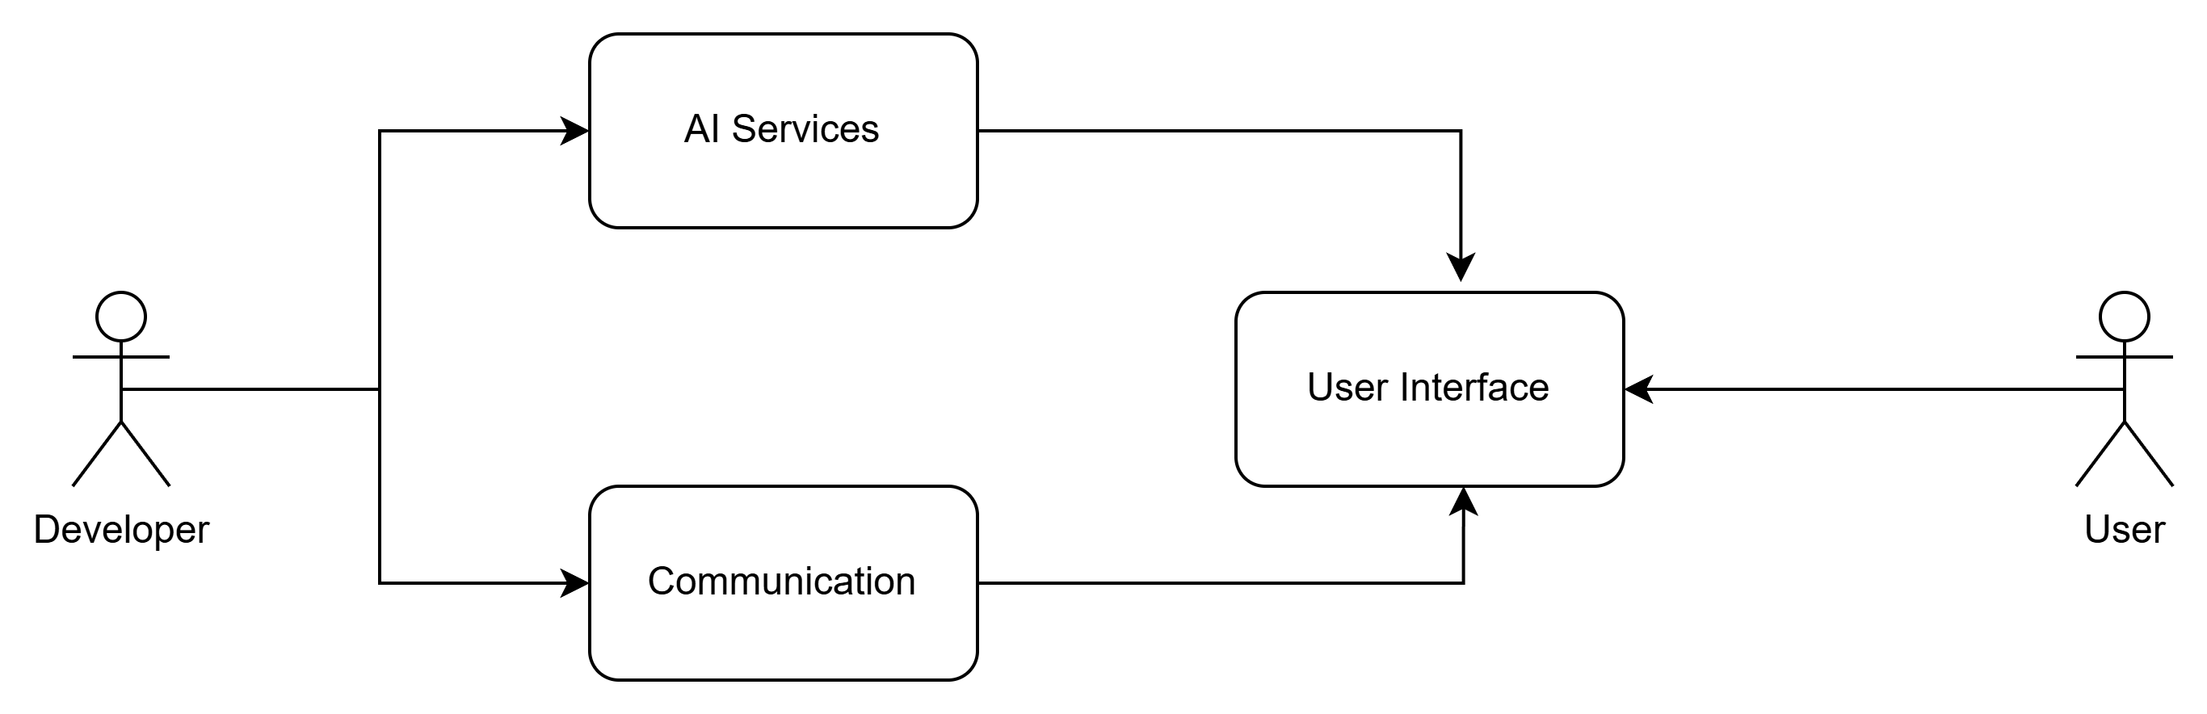

Figure 8: Package Diagram of the Learn-Link

Figure 8 above shows the package diagram of the whole Learn-Link. Users can use the system via User Interface which connects hardware and software parts of the system.
Developer manages interaction between parts.

Detailed component diagram is given in section 5.3 and class diagram given in section 5.4.

5.9.3 Example languages
UML package diagram showing interaction between the parts of the system and the user has been given in the previous sections by using UML modeling language.

5.10 Interaction viewpoint
In this section, main functionalities of the system are given by the help of sequence diagrams. Moreover, it defines strategies for interaction among entities.

5.10.1 Design Concerns
For designers, this section includes evaluating allocation of responsibilities in collaborations and description of interactions in terms of messages among affected objects in fulfilling required actions with the help of sequence diagrams.

5.10.2 Design Elements
Given sub-sections below, user and system interactions are illustrated.

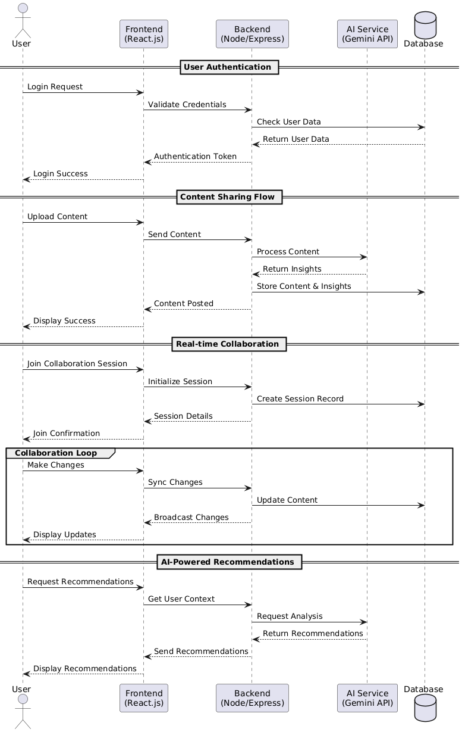
Figure 9: Sequence Diagrams for Learn-Link

The figure 9 explains Learn-Link platform utilizes a multi-layered architecture to deliver its collaborative and AI-driven features. User authentication is handled via a React.js frontend communicating with a Node/Express backend for validation and token generation. Content sharing involves uploads processed through the frontend, Gemini AI for enhancement, and storage in a database, with user confirmation upon completion. Real-time collaboration features a continuous loop of change detection, synchronization, database updates, and UI broadcasting to ensure all participants are live and in sync. Finally, AI-powered recommendations are generated by gathering user context, analyzing data with Gemini AI, and delivering tailored suggestions to the user. This integration of React.js, Node/Express, Gemini API, and a database enables real-time synchronization, AI-enhanced content processing, a seamless user experience, and a scalable architecture.
5.10.3 Examples Languages
Sequence diagrams which show how processes operate with one another and in what order has been given in the previous section by using UML modeling language.

5.11 State Dynamics Viewpoint
In this section, system behavior and states of the system are given via the state transition diagram.

5.11.1 Design Concerns
Designers, developers and testers are informed about the dynamic view of the system which includes modes, states, transitions and reactions to events.

5.11.2 Design elements
The different states of Learn-Link Software and how they interact with each other are specified in the figure given below:
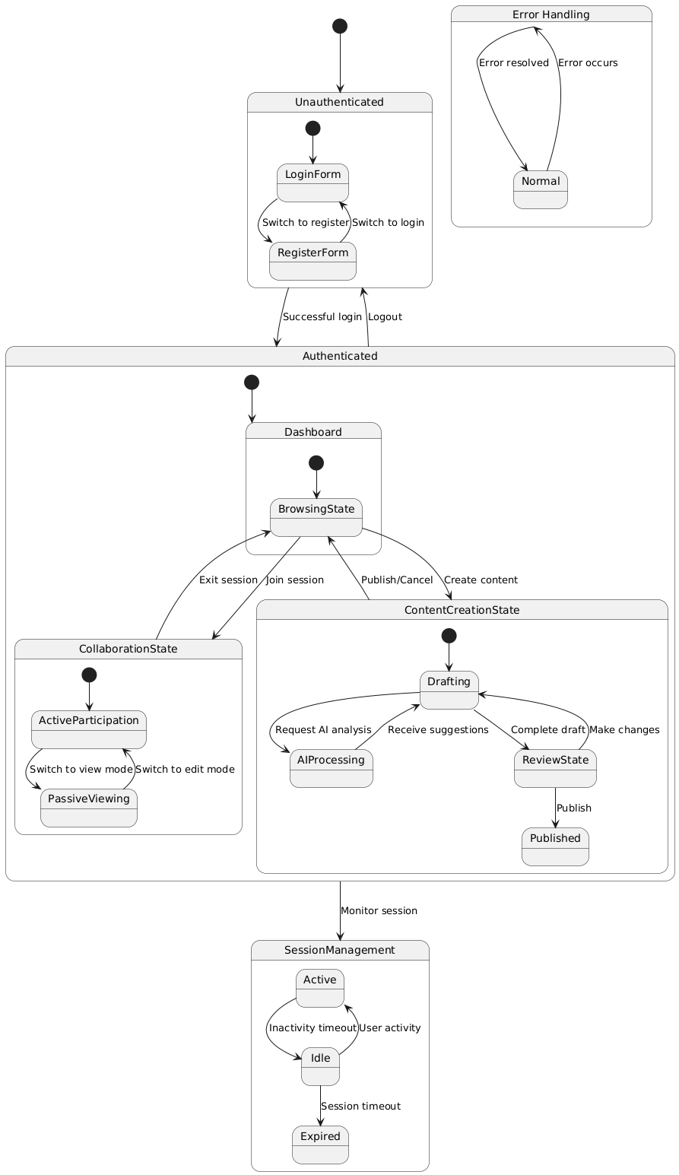
Figure 12: State Machine Diagram of the Learn-Link

5.11.3 Example languages
State machine diagram given in the previous section which shows the internal behavior of the system by state transitions is created by the UML.

